**ECE 20100 – Fall 2016**

**Exam #1**

**September 22, 2016**

**Sections (include on scantron)**

Hosseini (9:30) – 0002 Peleato-Inarrea (3:30) – 0004 Michelusi (1:30) – 0005

Qi (10:30) – 0011 Cui (8:30) – 0012

Peroulis (11:30) – 0013 Kildishev (1:30) – 0014

Name ____________________________ PUID____________

***Instructions***

1. DO NOT START UNTIL TOLD TO DO SO.
2. Write your name, section, professor, and student ID# on your **Scantron** sheet. We may check PUIDs.
3. This is a CLOSED BOOKS and CLOSED NOTES exam.
4. The use of a TI-30X IIS calculator is allowed, but not necessary.
5. If extra paper is needed, use the back of test pages.
6. Cheating will not be tolerated and will be dealt with according to the policy in your section. In particular, **continuing to write after the exam time is up is regarded as cheating**.
7. If you cannot solve a question, be sure to look at the other ones, and come back to it if time permits.
8. ***All of the problems*** on Exam #1 provide evidence for satisfaction of this ECE 20100 Learning Objective:

i) An ability to analyze linear resistive circuits.

The minimum score needed to satisfy this objective will be posted on Blackboard after the exam has been graded. Remediation options will be posted in Blackboard if you fail to satisfy any of the course outcomes.

**Question 1**

What is the power consumed by the resistor below?

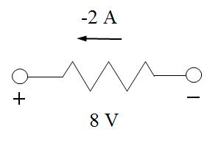

1. 4 W
2. 12 W
3. 16 W
4. 0 W
5. – 4 W
6. – 12 W
7. – 16 W
8. None of the above

**Question 2**

Two parallel plates are charged with 2 Coulombs (positive on one, negative on the other). At time t = 0, a resistor is connected between the plates and the charge on the positive plate decreases as follows:

q(t) = 2 e - t/2

Which of the following plots represents the current **from the positive to the negative** plate?



1) 2)



3) 4)



5) 6)

**Question 3**

In the following circuit, find the conductance of the resistor, G:

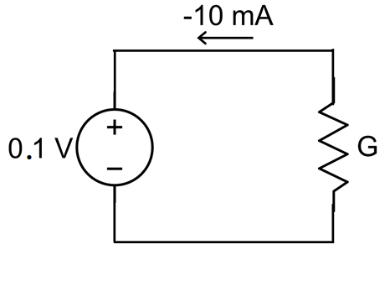

1. – 10 S
2. – 10 Ω
3. – 0.1 S
4. – 0.1 Ω
5. 0.01 S
6. 0.01 Ω
7. 0.1 S
8. 0.1 Ω
9. 10 Ω
10. None of the above

Answer (7)

**Question 4**

In the circuit shown below, all the resistors have the same resistance R. Find the voltage Vx.

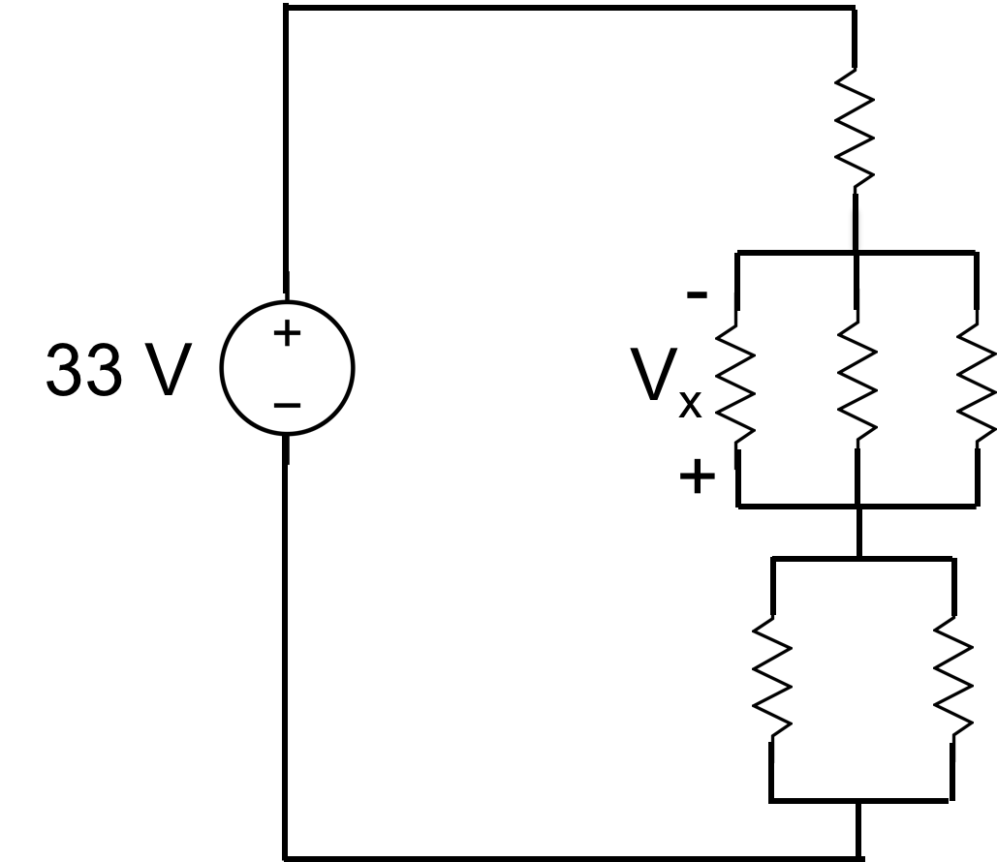

1. – 16.5 V
2. – 11 V
3. – 6 V
4. – 5.5 V
5. 0 V
6. 5.5 V
7. 6 V
8. 11 V
9. 16.5 V
10. None of the above

Answer (3)

**Question 5**

In the circuit below, find current *I1*:

3 A

2 A

*I1*

1 A

1. 1 A
2. 2 A
3. 3 A
4. 4 A
5. 5 A
6. 6 A
7. 0 A
8. – 1 A
9. – 2 A
10. None of the above

Answer (6)

**Question 6**

Find the value for current *I2* in the following circuit.

*I*2

1 A

*V*1

2 

6 

*3V*1

+

-

30 

1. 1 A
2. 2 A
3. 3 A
4. 4 A
5. 5 A
6. 6 A
7. 0 A
8. – 1 A
9. – 2 A
10. None of the above

Answer (5)

**Question 7**

For the circuit below, please find the voltage of the node A. *Hint:* Use Nodal Analysis.

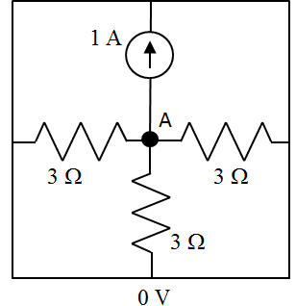

1. 3 V
2. 2 V
3. 1 V
4. 0 V
5. – 1 V
6. – 2 V
7. – 3 V
8. None of the above

**Question 8**

Using nodal analysis, find the nodal voltage VA (in V). Note: all resistors are identified by their conductance.

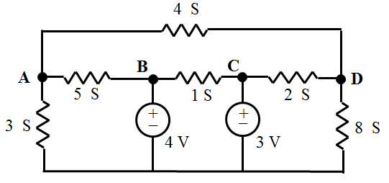

(1) 1

(2) 2

(3) 3

(4) 4

(5) 5

(6) 6

(7) 7

(8) 8

(9) None of the above

**Question 9**

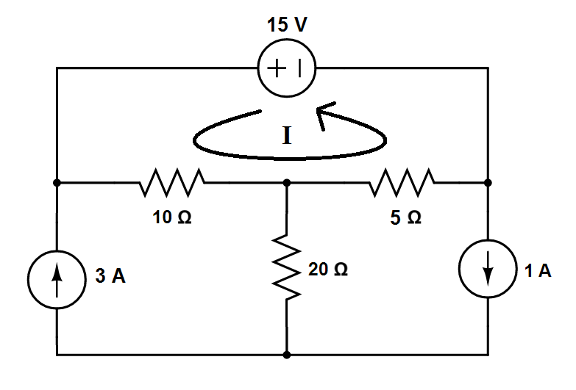

Which of the following is the correct loop equation for the circuit above?

$-15+10×\left(I-3\right)-5×\left(I-1\right)=0$

$-15-10×\left(I+3\right)+5×\left(I-1\right)=0$

$-15+10×\left(I-3\right)-5×\left(I+1\right)=0$

$-15+10×\left(I+3\right)+5×\left(I+1\right)=0$

$15+10×\left(I-3\right)-5×\left(I-1\right)=0$

$15-10×\left(I+3\right)+5×\left(I-1\right)=0$

$15+10×\left(I-3\right)-5×\left(I+1\right)=0$

$15+10×\left(I+3\right)+5×\left(I+1\right)=0$

2. None of the above

**Question 10**

Use the principle of superposition to find a difference V0 – V01 in the circuit shown in the figure below, provided that *v*0 is defined for voltage and current sources acting together while *v*01 is given when only the current sources are acting.

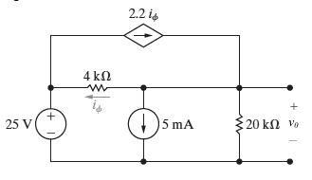

1. V0 – V01 = 19.5 V
2. V0 – V01 = – 50.0 V
3. V0 – V01 = 17.5 V
4. V0 – V01 = 30.0 V
5. V0 – V01 = 0 V
6. V0 – V01 = – 0.3 V
7. V0 – V01 = 11.6 V
8. V0 – V01 = – 30 V
9. None of the above

**Question 11**

In the circuit below, we vary the voltage value of the two sources v1 and v2 and measure the voltage drop vout on the resistor R3. The measurement (unit V) is summarized in the table below. Find the voltage value of vout for v1 = 2 V and v2 = 4 V.

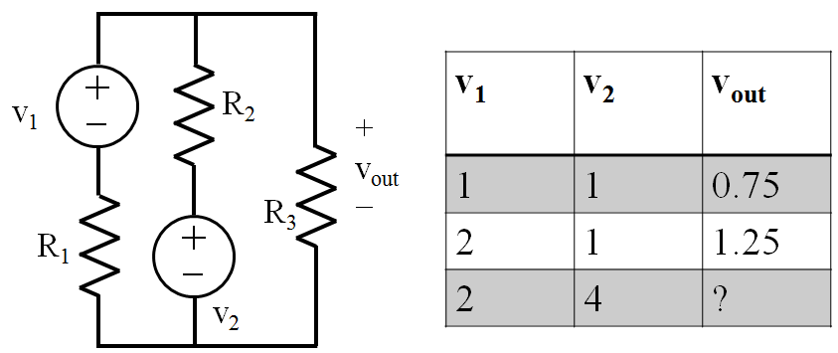

1. 0 V
2. 1 V
3. 1.5 V
4. 2 V
5. 2.5 V
6. 3 V
7. None of the above

Answer: (4)

**Question 12**

In the circuit below, find the voltage drop vAB.

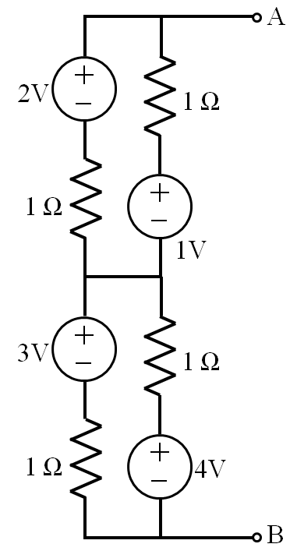

1. 0 V
2. 2 V
3. 3V
4. 4 V
5. 5 V
6. 6 V
7. 7 V
8. 10 V
9. None of the above

Answer (5)